***Western Blot Protocol***

* Cell collection (6-well)

1. Wash cell with cold PBS
2. Add 200 uL of RIPA +PIC+phosphatase inhibitor

*RIPA = radioimmunoprecipitation assay buffer (lysis)

*PIC = protease inhibitor cocktail ; stock 25x (1 tablet in 2 mL water or PBS)

*phosphatase inhibitor stock 100x

All these buffer on ice

1. Collect cell pellets with cell scraper in 1.5 mL tubes
2. Spin and rotate in cold room 30 mins

*can add buffer mix and bring the plate on the shaker in cold room and collect the cell pellet later

1. Spin maximum speed 10 mins
2. Collect supernatant

*Pause point: keep supernatant in -20*c

* BCA rapid

*96-well transparent plate

*duplicate or triplicate

<Preparing at least 5 standard BSA (Bovine serum albumin) Stock BSA at 2 mg/mL, linear working range for BSA of 20 to 2000 µg/mL >

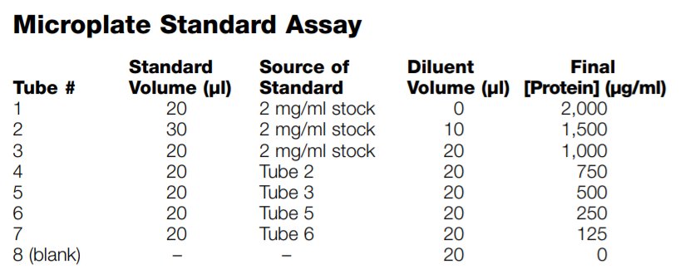

1. Load 5 uL samples/std in the 96-well plate on ice
2. Prepare BCA rapid gold solution reagent A:B = 50 : 1
3. Add 100 uL BCA solution using multichannel, pipetting, beware of bubbles

*the color change according to vol, time of reaction

1. Incubate at RT for at least 5 mins
2. Measure Absorbance 480 nm
3. Back calculate protein concentration from the standard curve

* SDS-Gel running

[SDS gel protocol-Biorad](https://www.bio-rad.com/webroot/web/pdf/lsr/literature/Bulletin_6040.pdf)

1. Choose the smallest concentration as the baseline; good range is 20-25 ug/well and dilute with RIPA buffer to make all samples have equal protein

E.g.

|  |  |  |  |  |
| --- | --- | --- | --- | --- |
| Sample | Conc (ug/mL) | Vol(uL) | RIPA(uL) | Protein(ug) |
| 1 | 600 | 30 | 0 | 18 |
| 2 | 900 | 20 | 10 | 18 |
| 3 | 1630 | 11 | 19 | 18 |

1. Prepare Laemmli sample buffer by adding a reducing agent (1:19)

5 uL DTT + 95 uL 4xLaemmli

1. Dilute sample with 4xLaemmli (3:1)

E.g. 1 lane = 30 uL sample + 10uL 4x Laemmli

1. Spin down and incubate at 99*c for 10 mins
2. Choose appropriate pre-cast SDS gel concentration 4-20%, fill in some running buffer
3. Remove the strip on the lower end, put in the dock (the shorter plate go in front), fill the buffer to the level, remove the comb
4. 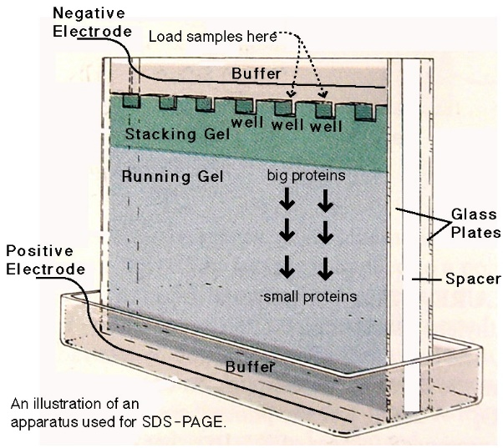
5. Load 25-30 (max35) uL samples, 5 uL protein ladder

Don't leave empty wells; add loading buffer to prevent skew protein migration

1. Set up : 150 V for 90 mins or until the loading dye go to the end (time not really matter)

* Transfer (Dry with iBlot)

1. Keep gel in buffer at all time
2. Soak the membrane in a milliQ
3. Crack gel open carefully, remove stacking part, cut gel from all margins
4. Put gel on a membrane without touching the protein in order (see instruction), use roller to eliminate air bubbles

*arrange the top of the gel (higher kDa) toward the center of the membrane (higher electricity)

1. Turn the iBlot on :P0 protocol 7 mins

* Antibody staining

*do not touch the blot, non-specific background

1. Cut membrane according to interested protein size
2. Blocking with 5% BSA/Milk/blocking buffer for 30-60 mins on rocker at RT or overnight at 4oc
3. Incubate the membrane with primary Ab in blocking buffer overnight at 4oc on rocker

* 1* Ab can be reused, common concentration = 1:1000

1. Wash with TBST 5 mins x3
2. Incubate the membrane with fluorescent secondary Ab in blocking buffer at RT 1hr

Commonly use Rabbit 800, Mouse 680 at 1:2000-4000

1. Wash with TBST 5 mins x3
2. Image blot with Odyssey